**By :- Abhishek Gupta (501824)**

**“MySql Project”**

**\***

**“College DataBase”**

**Introduction :-**

This Project covers of Login page, Creation of user ,Instructor , Student and Department tables , which are in the backend Connected to MySQL Database.

The Main AIM of this project is that Any person even with no knowledge of Mysql can enter data , retrieve data and Modify data with ease.

In Each Interface ,Authorised Users has option to Insert, Update, Delete and Modify certain data with the help of GUI .The Individuals also has the Priviledge to even see the contents of the table in a table manner as shown below in Instructor Page.

**Design :-**

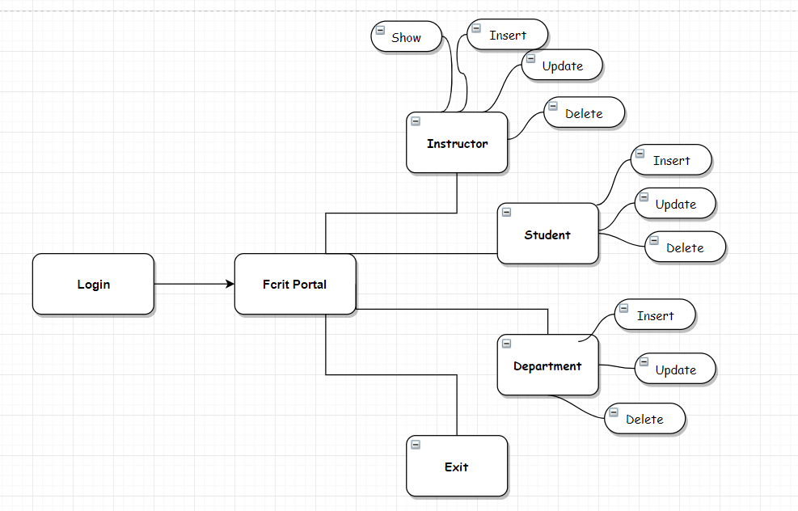

**Code :-**

**# Login Page :-**

MySql Query :-

1. ***Creation Of Users***

CreateUsers

1. ***Contents of Users Table***

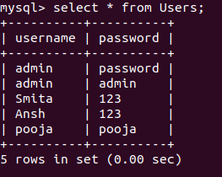

# ***Code*** :-

package university;

import java.sql.Connection;

import java.sql.DriverManager;

import java.sql.PreparedStatement;

import java.sql.ResultSet;

import java.sql.SQLException;

import java.util.logging.Level;

import java.util.logging.Logger;

import javax.swing.JOptionPane;

public class SignUp extends javax.swing.JFrame {

public SignUp() {

initComponents();

}

private void resetActionPerformed(java.awt.event.ActionEvent evt) {

username.setText(null);

password.setText(null);

}

private void exitActionPerformed(java.awt.event.ActionEvent evt) {

System.exit(0);

}

private void loginActionPerformed(java.awt.event.ActionEvent evt) {

try {

Class.forName("com.mysql.jdbc.Driver");

Connection con = DriverManager.getConnection("jdbc:mysql://localhost:3306/College_project","root","9821476621");

String query = "select * from Users where username =? and password =? ";

if (username.getText() != null && password.getText() != null)

{

PreparedStatement ps = con.prepareStatement(query);

ps.setString(1,username.getText());

ps.setString(2,password.getText());

ResultSet rs = ps.executeQuery();

if (rs.next())

{

new Portals().setVisible(true);

this.setVisible(false);

}

else

{

username.setText(null);

password.setText(null);

JOptionPane.showMessageDialog(null,"Please Enter Valid Details ....");

}

}

else {

JOptionPane.showMessageDialog(null,"Both Feilds are Compulsory .....");

}

}

catch (ClassNotFoundException ex) {

Logger.getLogger(SignUp.class.getName()).log(Level.SEVERE, null, ex);

}

catch (SQLException ex) {

Logger.getLogger(SignUp.class.getName()).log(Level.SEVERE, null, ex);

}

}

private void CreateActionPerformed(java.awt.event.ActionEvent evt) {

new CreateUser().setVisible(true);

this.setVisible(false);

}

public static void main(String args[]) {

java.awt.EventQueue.invokeLater(new Runnable() {

public void run() {

new SignUp().setVisible(true);

}

});

}

// Variables declaration - do not modify

private javax.swing.JButton Create;

private javax.swing.JButton exit;

private javax.swing.JLabel jLabel1;

private javax.swing.JLabel jLabel2;

private javax.swing.JLabel jLabel3;

private javax.swing.JLabel jLabel4;

private javax.swing.JPanel jPanel1;

private javax.swing.JButton login;

private javax.swing.JPasswordField password;

private javax.swing.JButton reset;

private javax.swing.JTextField username;

// End of variables declaration

}

**# Login Page :-**

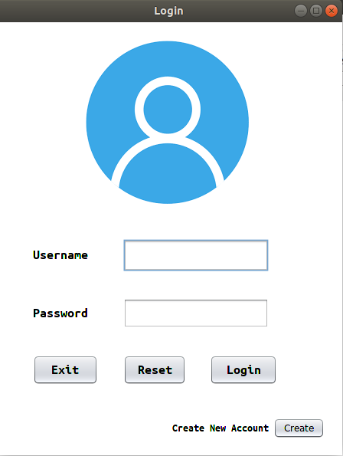

**# Create User Page :-**

public class CreateUser extends javax.swing.JFrame {

public CreateUser() {

initComponents();

}

private void loginActionPerformed(java.awt.event.ActionEvent evt) {

new SignUp().setVisible(true);

this.setVisible(false);

}

private void submitActionPerformed(java.awt.event.ActionEvent evt) {

Connection con =null;

try {

Class.forName("com.mysql.jdbc.Driver");

con = DriverManager.getConnection("jdbc:mysql://localhost:3306/College_project","root","9821476621");

if (username.getText() != null && password.getText() != null)

{

String query = "select * from Users where username =? and password =? ";

if (username.getText() != null && password.getText() != null)

{

PreparedStatement ps = con.prepareStatement(query);

ps.setString(1,username.getText());

ps.setString(2,password.getText());

ResultSet rs = ps.executeQuery();

if (rs.next())

{

JOptionPane.showMessageDialog(null,"Username or password already exists .. Please Enter New details ..");

}

else

{

String query1 = "Insert into Users (username,password) values (?,?) ";

try {

PreparedStatement ps1 = con.prepareStatement(query1);

ps1.setString(1,username.getText());

ps1.setString(2,password.getText());

ps1.execute();

username.setText(null);

password.setText(null);

JOptionPane.showMessageDialog(null,"Account Created Successfully ...");

}

catch (Exception e)

{

JOptionPane.showMessageDialog(null, e);

} } }

}

else {

JOptionPane.showMessageDialog(null,"Both Feilds are Compulsory .....");

}

}

catch (ClassNotFoundException ex) {

Logger.getLogger(CreateUser.class.getName()).log(Level.SEVERE, null, ex);

}

catch (SQLException ex) {

Logger.getLogger(CreateUser.class.getName()).log(Level.SEVERE, null, ex);

}

}

public static void main(String args[]) {

java.awt.EventQueue.invokeLater(new Runnable() {

public void run() {

new CreateUser().setVisible(true);

} });}

**# Create User Page :-**

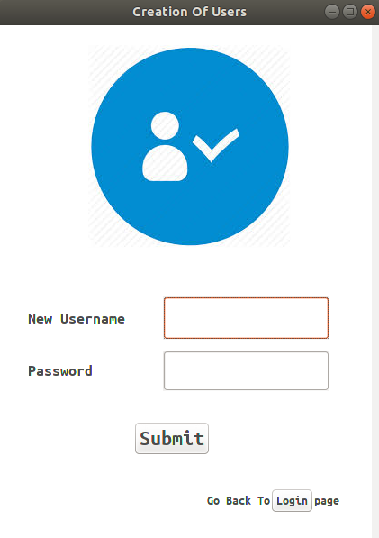

**# Instructor Page :-**

MySql Query :-

1. **Creation of Instructor2 Table**



1. **Contents of Instructor2 Table**

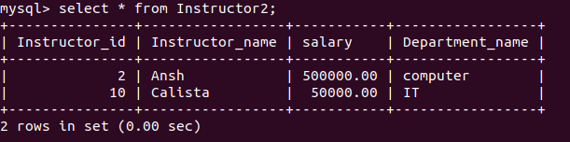

# Code :-

public class Instructor extends javax.swing.JFrame {

public Instructor() {

initComponents();

//MySqlConnection();

Display();

}

public void Display() {

DefaultTableModel tablemodel = (DefaultTableModel) table.getModel();

try {

Connection con =null;

Class.forName("com.mysql.jdbc.Driver");

con = DriverManager.getConnection("jdbc:mysql://localhost:3306/College_project","root","9821476621");

String query = "select * from Instructor2";

tablemodel.setRowCount(0);

Statement st = con.createStatement();

ResultSet rs = st.executeQuery(query);

while(rs.next())

{

int Id = rs.getInt("Instructor_id");

String Name = rs.getString("Instructor_name") ;

double Salary = rs.getDouble("salary");

String Department = rs.getString("Department_name");

tablemodel.addRow(new Object[]{Id,Name,Salary,Department});

}

}

catch (ClassNotFoundException | SQLException | NumberFormatException | HeadlessException e) {

JOptionPane.showMessageDialog(null,e);

}

}

private void exitActionPerformed(java.awt.event.ActionEvent evt) {

System.exit(0);

}

private void insertActionPerformed(java.awt.event.ActionEvent evt) {

try {

Connection con =null;

Class.forName("com.mysql.jdbc.Driver");

con = DriverManager.getConnection("jdbc:mysql://localhost:3306/College_project","root","9821476621");

String query = "Insert into Instructor2 (Instructor_id,Instructor_name,salary,Department_name) values (?,?,?,?) ";

try (PreparedStatement ps = con.prepareStatement(query)) {

ps.setInt(1, Integer.parseInt(id.getText()));

ps.setString(2,name.getText());

ps.setDouble(3,Double.parseDouble(salary.getText()));

ps.setString(4,department.getText());

ps.execute();

}

Display();

}

catch (ClassNotFoundException | SQLException | NumberFormatException | HeadlessException e) {

JOptionPane.showMessageDialog(null,e);

}

}

private void deleteActionPerformed(java.awt.event.ActionEvent evt) {

try {

Connection con =null;

Class.forName("com.mysql.jdbc.Driver");

con = DriverManager.getConnection("jdbc:mysql://localhost:3306/College_project","root","9821476621");

String query = "Delete from Instructor2 where Instructor_id = ? ";

try (PreparedStatement ps = con.prepareStatement(query)) {

ps.setInt(1, Integer.parseInt(id.getText()));

ps.execute();

}

Display();

}

catch (ClassNotFoundException | SQLException | NumberFormatException | HeadlessException e) {

JOptionPane.showMessageDialog(null,e);

}

}

private void updateActionPerformed(java.awt.event.ActionEvent evt) {

try {

Connection con =null;

Class.forName("com.mysql.jdbc.Driver");

con = DriverManager.getConnection("jdbc:mysql://localhost:3306/College_project","root","9821476621");

String query = "Update Instructor2 set Instructor_name =? , salary =? , Department_name = ? where Instructor_id = ?";

try (PreparedStatement ps = con.prepareStatement(query)) {

ps.setInt(4, Integer.parseInt(id.getText()));

ps.setDouble(2,Double.parseDouble(salary.getText()));

ps.setString(3,department.getText());

ps.setString(1,name.getText());

ps.execute();

}

Display();

}

catch (ClassNotFoundException | SQLException | NumberFormatException | HeadlessException e) {

JOptionPane.showMessageDialog(null,e);

}

}

private void jButton1ActionPerformed(java.awt.event.ActionEvent evt) {

new Portals().setVisible(true);

this.setVisible(false);

}

private void editActionPerformed(java.awt.event.ActionEvent evt) {

DefaultTableModel model = (DefaultTableModel) table.getModel();

int row = table.getSelectedRow();

String Id = model.getValueAt(row, 0).toString();

String Name = (String) model.getValueAt(row, 1);

String Salary = model.getValueAt(row, 2).toString();

String Department = (String) model.getValueAt(row, 3);

id.setText(Id);

name.setText(Name);

salary.setText(Salary);

department.setText(Department);

}

public static void main(String args[]) {

java.awt.EventQueue.invokeLater(new Runnable() {

public void run() {

new Instructor().setVisible(true);

}

});}

**# Instructor Page :-**

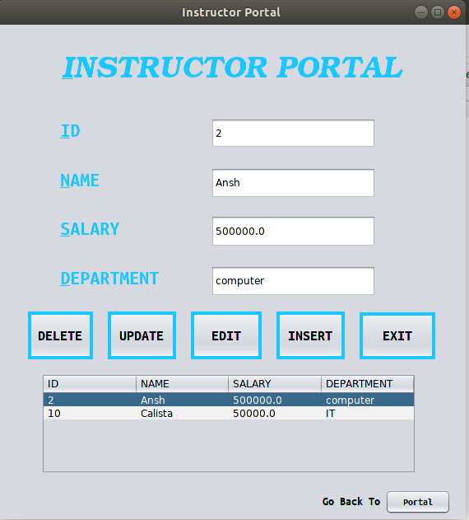

**References :-**

* JDBC Tutorial by “Genuine Coder” (Youtube)
* JDBC Manual (Official Website)